Use of Reclamation’s Post 2026 DMDU Tool

<https://tool.crbpost2026dmdu.org/>

**Performance Tradeoffs**

1. **Late 2030s Drought**

1. 11 maf, infrequent high flows

1. Early High Flows, then 12 maf

1. Decreasing Trend From 12 to 10 maf

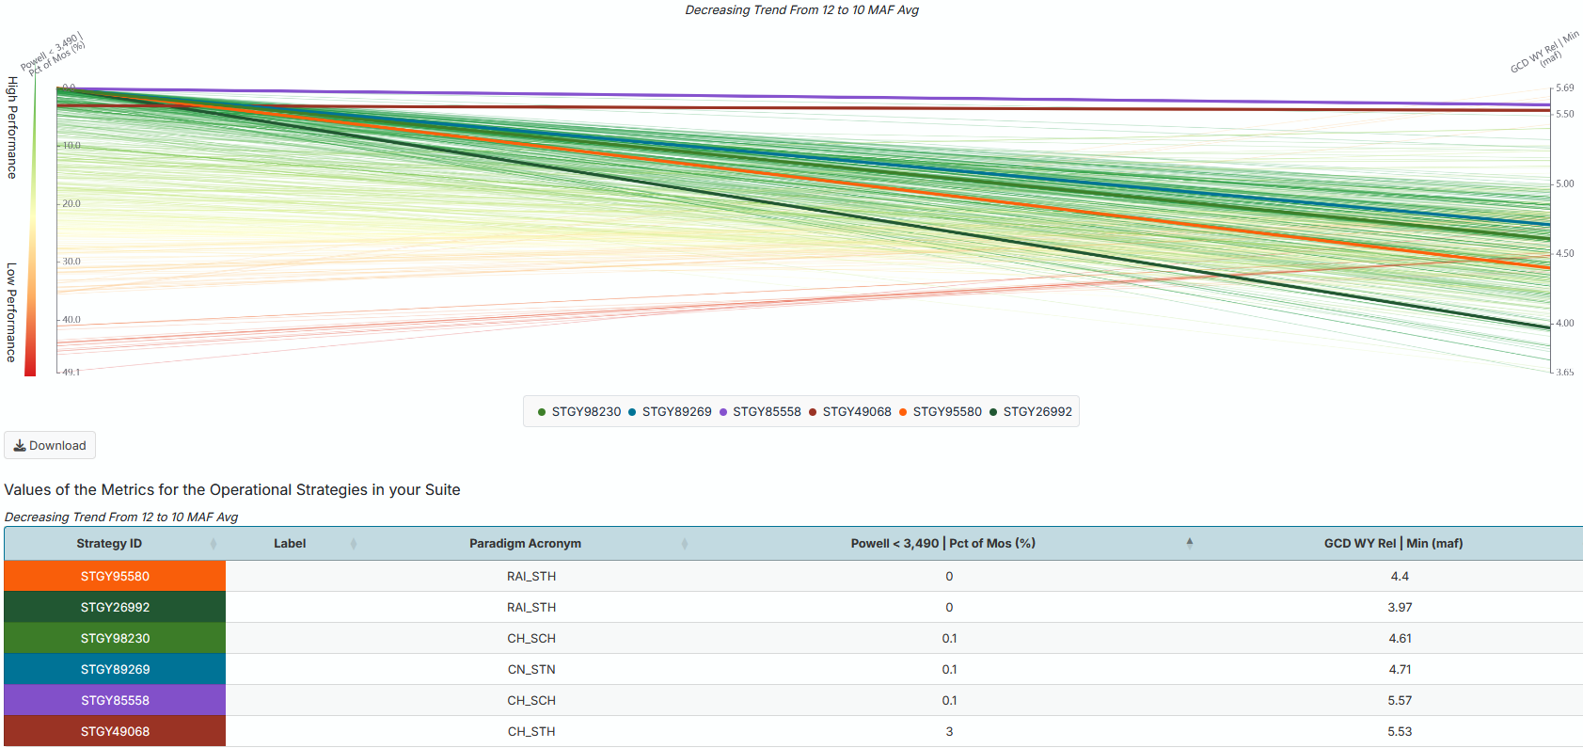

1. Drought through 2028 then 11.5 maf

1. Default Optimization

Vulnerability

